Figure 1
Elements of the Integrated Lesson Plan
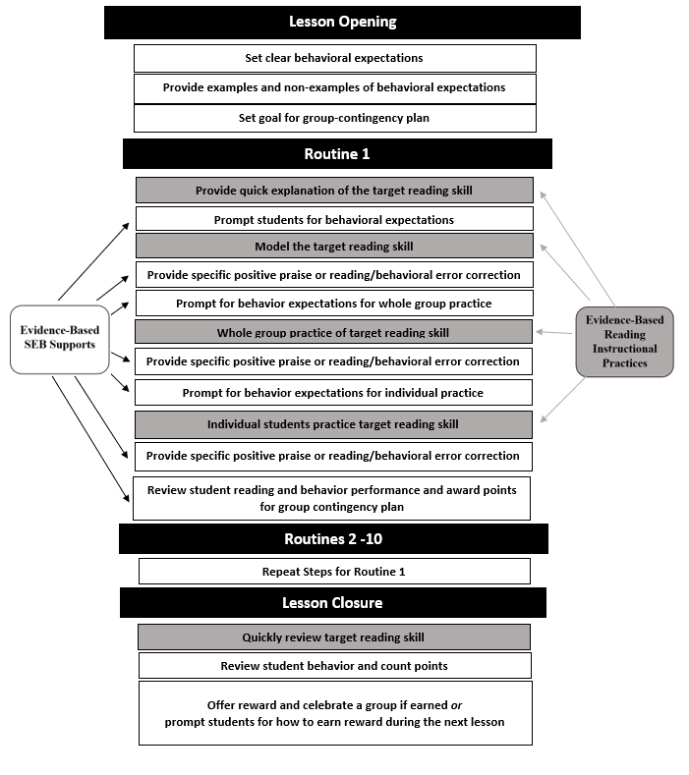

Figure 2
Integrated Template for Mr. Roja’s Phoneme Blending Routine
Routine: Phoneme blending
Target Words or Sounds to Practice: plate, wake, base, made, sale
MODEL
Explanation of Target Skill:
We are going to practice blending the sounds into words. First, I will say the sounds. When I say “word,” you will blend the sounds into a word.
Behavior Prompt:
Remember to be respectful by having your voice off when it’s my turn and by staying in your seat.
Model:
My turn. Listen to how I blend the sounds into a word. /p/ /l/ /ā/ /t/. What word? plate.
Behavior Specific Praise:
I love how you were all respectful listeners while I blended the word plate.
WHOLE GROUP PRACTICE
Prompt for Whole Group Practice:
Now, it’s your turn! When I say “Word?,” say the word out loud. Be safe and responsible by staying in your seat. Be respectful by waiting for my signal to say the word out loud.
Whole Group Practice:
*Blend words fake, wake, base, made, sale
Specific Feedback for Reading and Behavior:
Specific Praise:
- Reading - Excellent job blending the sounds into words
- Behavior - You are being very respectful and responsible by staying in your seats.
Corrective Feedback:
- Reading – My turn. The word is “____” Watch me blend. /_/ /_/ /_/. Word: ‘_____.’ Your turn.”
- Behavior – Remember to be respectful/responsible by _________. You earn points when you are respectful/responsible.
INDIVIDUAL TURNS
Prompt for Individual Practice:
Now I’m going to call on some of you to practice blending on your own! Remember to be respectful by having your voices off while it’s your friend’s turn.
Individual Practice:
Call on 3-4 students for individual practice.
Specific Feedback for Reading and Behavior:
Specific Praise:
- Reading - Excellent job blending the sounds in the word!
- Behavior - You are being very respectful by having your voices off when it’s your friend’s turn.
Corrective Feedback:
- Reading – My turn. The word is “____” Watch me blend. /_/ /_/ /_/. Word: ‘_____.’ Your turn.”
- Behavior – Remember to be respectful/responsible by _________. You earn points when you are respectful and responsible.
ROUTINE REVIEW
Nice work blending words! You were responsible by ____ and respectful by ____. You earned ___ points!

