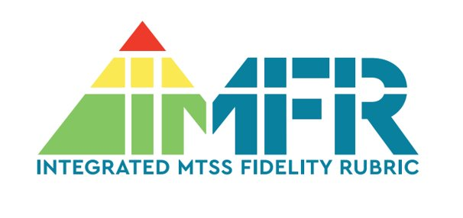
The purpose of the Integrated MTSS Fidelity Rubric (IMFR) study is to develop and validate a rubric to measure implementation of integrated MTSS (I-MTSS), for use by schools and districts (either external or self-administered), and by researchers studying MTSS. To date, over 80 school teams per year have participated in interviews to assess their fidelity of implementation of I-MTSS. In the spring of 2022, we co-presented with hosted two school teams at the annual Council for Exceptional Children conference in Orlando. The session was filled to capacity and participants thoroughly enjoyed hearing from the school team members and asking questions related to I-MTSS implementation. Below are comments and pictures from these two school teams, both of whom are entering their third year of participation in the study.
Elementary building team 1:
“Participating in the IMFR process provided us great insight into the things we’d like to work on, as well as helping us to recognize (and celebrate!) the great things that we’ve worked hard to put into place in our building already.
We knew that there were areas that we could grow in and the report helped provide clear data to help us identify that these areas were in fact something we could focus on. Based on previous data, we knew that our interventions for math and behavior were weaker, and the report not only helped confirm our thinking, but it also provided clear and thorough next steps to help guide us in the direction to make changes over time.
Since our building was not new to the intervention process, we had some of these things in place, but the next steps provided in the report have served as a great refresher and reminder of the resources that are available, along with new resources that we have not heard before.
Looking at the feedback, we identified ways that we could strengthen our Tier 1 instruction. Due to COVID, we haven’t been able to fully implement our interventions like we had in the past, so we wanted to address our Tier 1 interventions to start the year. One way that we are planning to do this is by having our instructional mentor focus on how to help our teachers successfully implement Tier 1 instruction.
Additionally, we are looking forward to seeing how our implementation of Second Step as a Tier 1 instruction has changed our data, especially as we work toward implementing the program more consistently in what we hope to be a “normal” year.
We are not only grateful for the feedback and resources we have received, but we are also appreciative of the opportunity to reflect on our building’s programs and practices.”
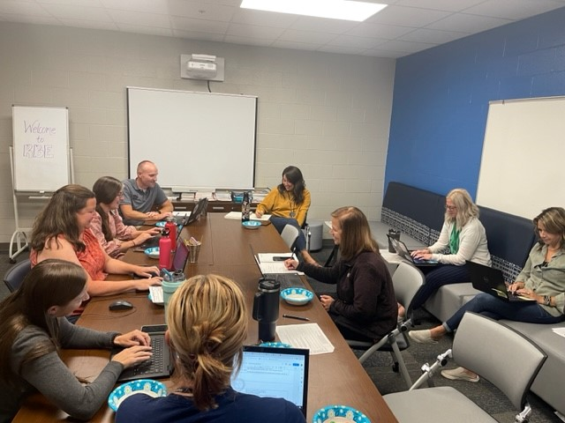
Elementary 1 IMTSS Leadership Team Meeting
Elementary building team 2
“We had the chance to travel with the amazing IMFR team from the University of Missouri this past school year to Orlando. The experience of presenting with other amazing educators about this program was such an incredible opportunity. We were able to talk about the impact the program did for our MTSS system in our building with fellow educators across the country. Hearing that what we are putting the best practices in place is a direct reflection of the IMFR program.

Before starting with the IMFR team, our MTSS program wasn't giving us much information. Our data wasn't moving, and we were struggling as an admin team to find areas that needed to be changed that would actually help. Going through the interview with the IMFR team took a little bit but the information that came from our interview changed our procedures and focus for our building. Our leadership team took the information and discussed it with their teams. We then talked as teams to make decisions for the betterment of our students and building procedures. Making that change wouldn't have happened without this program.

Now, we look forward to the interview each year so that we can use the data to better improve our process at our building. We really appreciate the time and effort the IMFR team puts in behind the scenes to help our students and staff. It is an opportunity that all educators should be able to experience.”

IMFR Elementary Building Team 2
